**Code Structure for Audio Reading Service Radios Project**

The purpose of this document is to provide an overview of the code structure, detailing what directories are included and what files lie where.

Link to GitHub for project code: <https://github.com/sharsz01/acplZend>  
Link to GitHub for Zend library: <https://github.com/sharsz01/Misc-Util-Files>

The root structure of the RadiosApp application is as follows:

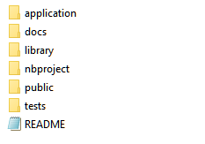

**Application**

The application directory contains the main code files for the admin interface, email, login, application forms, and views. The file structure is as follows:

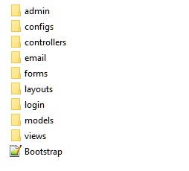

**Application/admin/ajax**

Contains the Ajax pages for the admin interface which handles the create, read, search and update functionalities as well as the files controlling the check-in check-out functionalities for the radios.

**Application/admin/importExport**

Contains the import.php file responsible for handling the ability to import data into the database or export out.

**Application/admin/tabs**

Contains the files controlling the display of the different tabs on the Admin interface such as the Alerts tab, the Listeners and Listener Details tabs (named userList.php and userDetails.php), the Organizations and Organization Details tabs, the Radios and Radio Details tabs, and the User Management tab.

**Application/admin/userControls**

Contains the files for adding new users (users allowed to manage the Admin interface) and updating the passwords of existing users.

The admin.php file contains the main file that controls which tabs are included in the display.

**Application/configs**

Contains the dbConnect.php file which specifies the host name, the user name, password and which database to use.

**Application/controllers**

Controls which actions to take for the forms. The only file that should need to be maintained in this directory is the RadioApplicationController.php file. This file controls the actions for the two application forms and specifies the actions to take when each form is submitted, what happens on success, and inserting form data into the database.

**Application/email**

Contains the files relating to sending out emails to listeners or organizations

**Application/forms**

Contains the files for the forms such as the radio application forms and the confirm form.

**Application/layouts**

Contains the layout structure for the website.

**Application/login**

Contains the code files relating to users logging in and out.

**Application/models**

Contains the files through which Zend_Db is used to insert the data from the application forms into the database. Zend_Db helps protect against SQL injections.

**Application/views/scripts**

Contains the files relating to the display of the page. The only file that should need to be maintained is the radio-application folder which contains the PHP files for the confirmation pages, headers, success, and application forms for both individual listeners and organizations.

The Bootstrap.php file should not need to be maintained.

**Docs**

The docs directory should contain any documentation, help guides, or licenses for this project.

**Libarary**

Contains the Zend 1.12 library. Needed for usage with the forms.

**Public**

Contains the CSS, JS, and SQL files. Also contains the main index.php file.

**Tests**

Contains any test files.